**DAILY ONLINE ACTIVITIES SUMMARY**

|  |  |  |  |  |  |  |  |  |
| --- | --- | --- | --- | --- | --- | --- | --- | --- |
| **Date:** | **4-07-2020** | | | | | **Name:** | **Sinchana** | |
| **Sem & Sec** | **6 B** | | | | | **USN:** | **4AL17CS117** | |
| **Online Test Summary** | | | | | | | | |
| **Subject** | |  | | | | | | |
| **Max. Marks** | |  | | **Score** | | |  | |
| **Certification Course Summary** | | | | | | | | |
| **Course** |  | | | | | | | |
| **Certificate Provider** | | |  | | **Duration** | | |  |
| **Coding Challenges** | | | | | | | | |
| **Problem Statement:** | | | | | | | | |
| **Status: Success** | | | | | | | | |
| **Uploaded the report in Github** | | | | | **Yes** | | | |
| **If yes Repository name** | | | | | **coding** | | | |
| **Uploaded the report in slack** | | | | | **Yes** | | | |

Online Test Details: (Attach the snapshot and briefly write the report for the same)

Certification Course Details: (Attach the snapshot and briefly write the report for the same)

Coding Challenges Details: (Attach the snapshot and briefly write the report for the same)

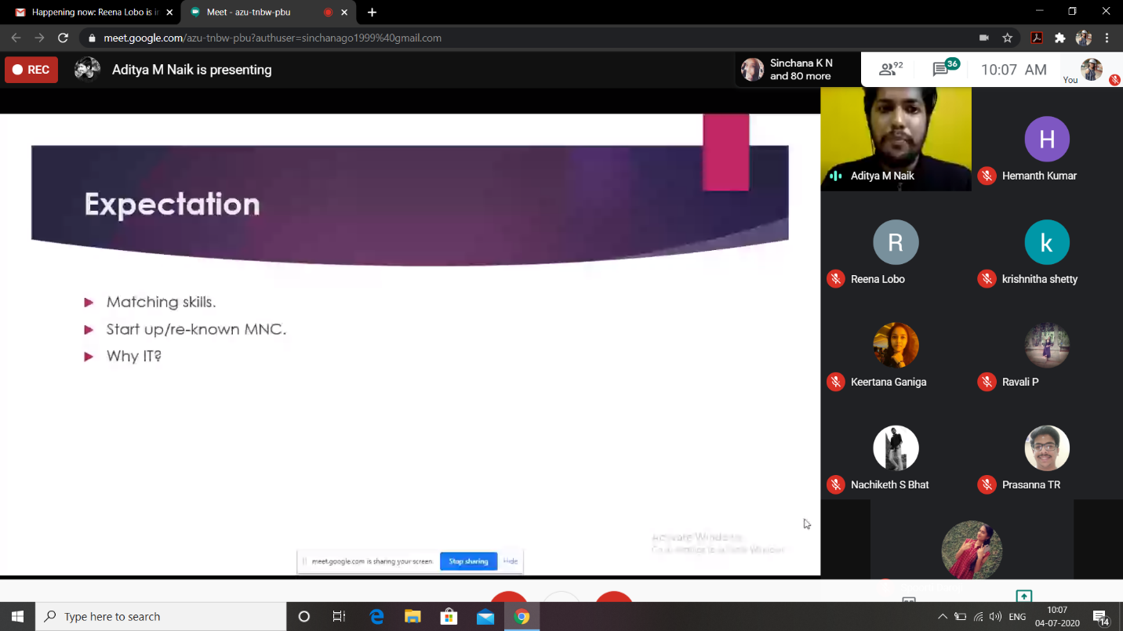

Link in Github :

1. Coding and Word document

<https://github.com/sinchana514/coding/upload/master/4th%20july>